Shoei Fast Fit

Creasing unit

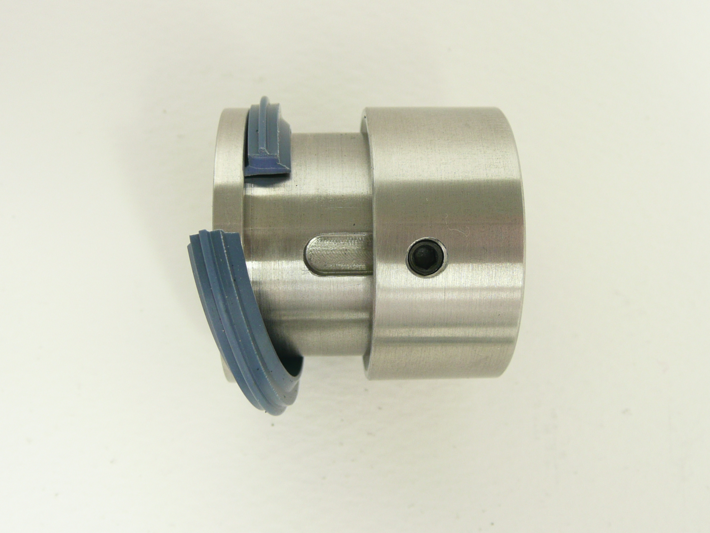
Loosen fixing screw and slide collar to remove creasing rib

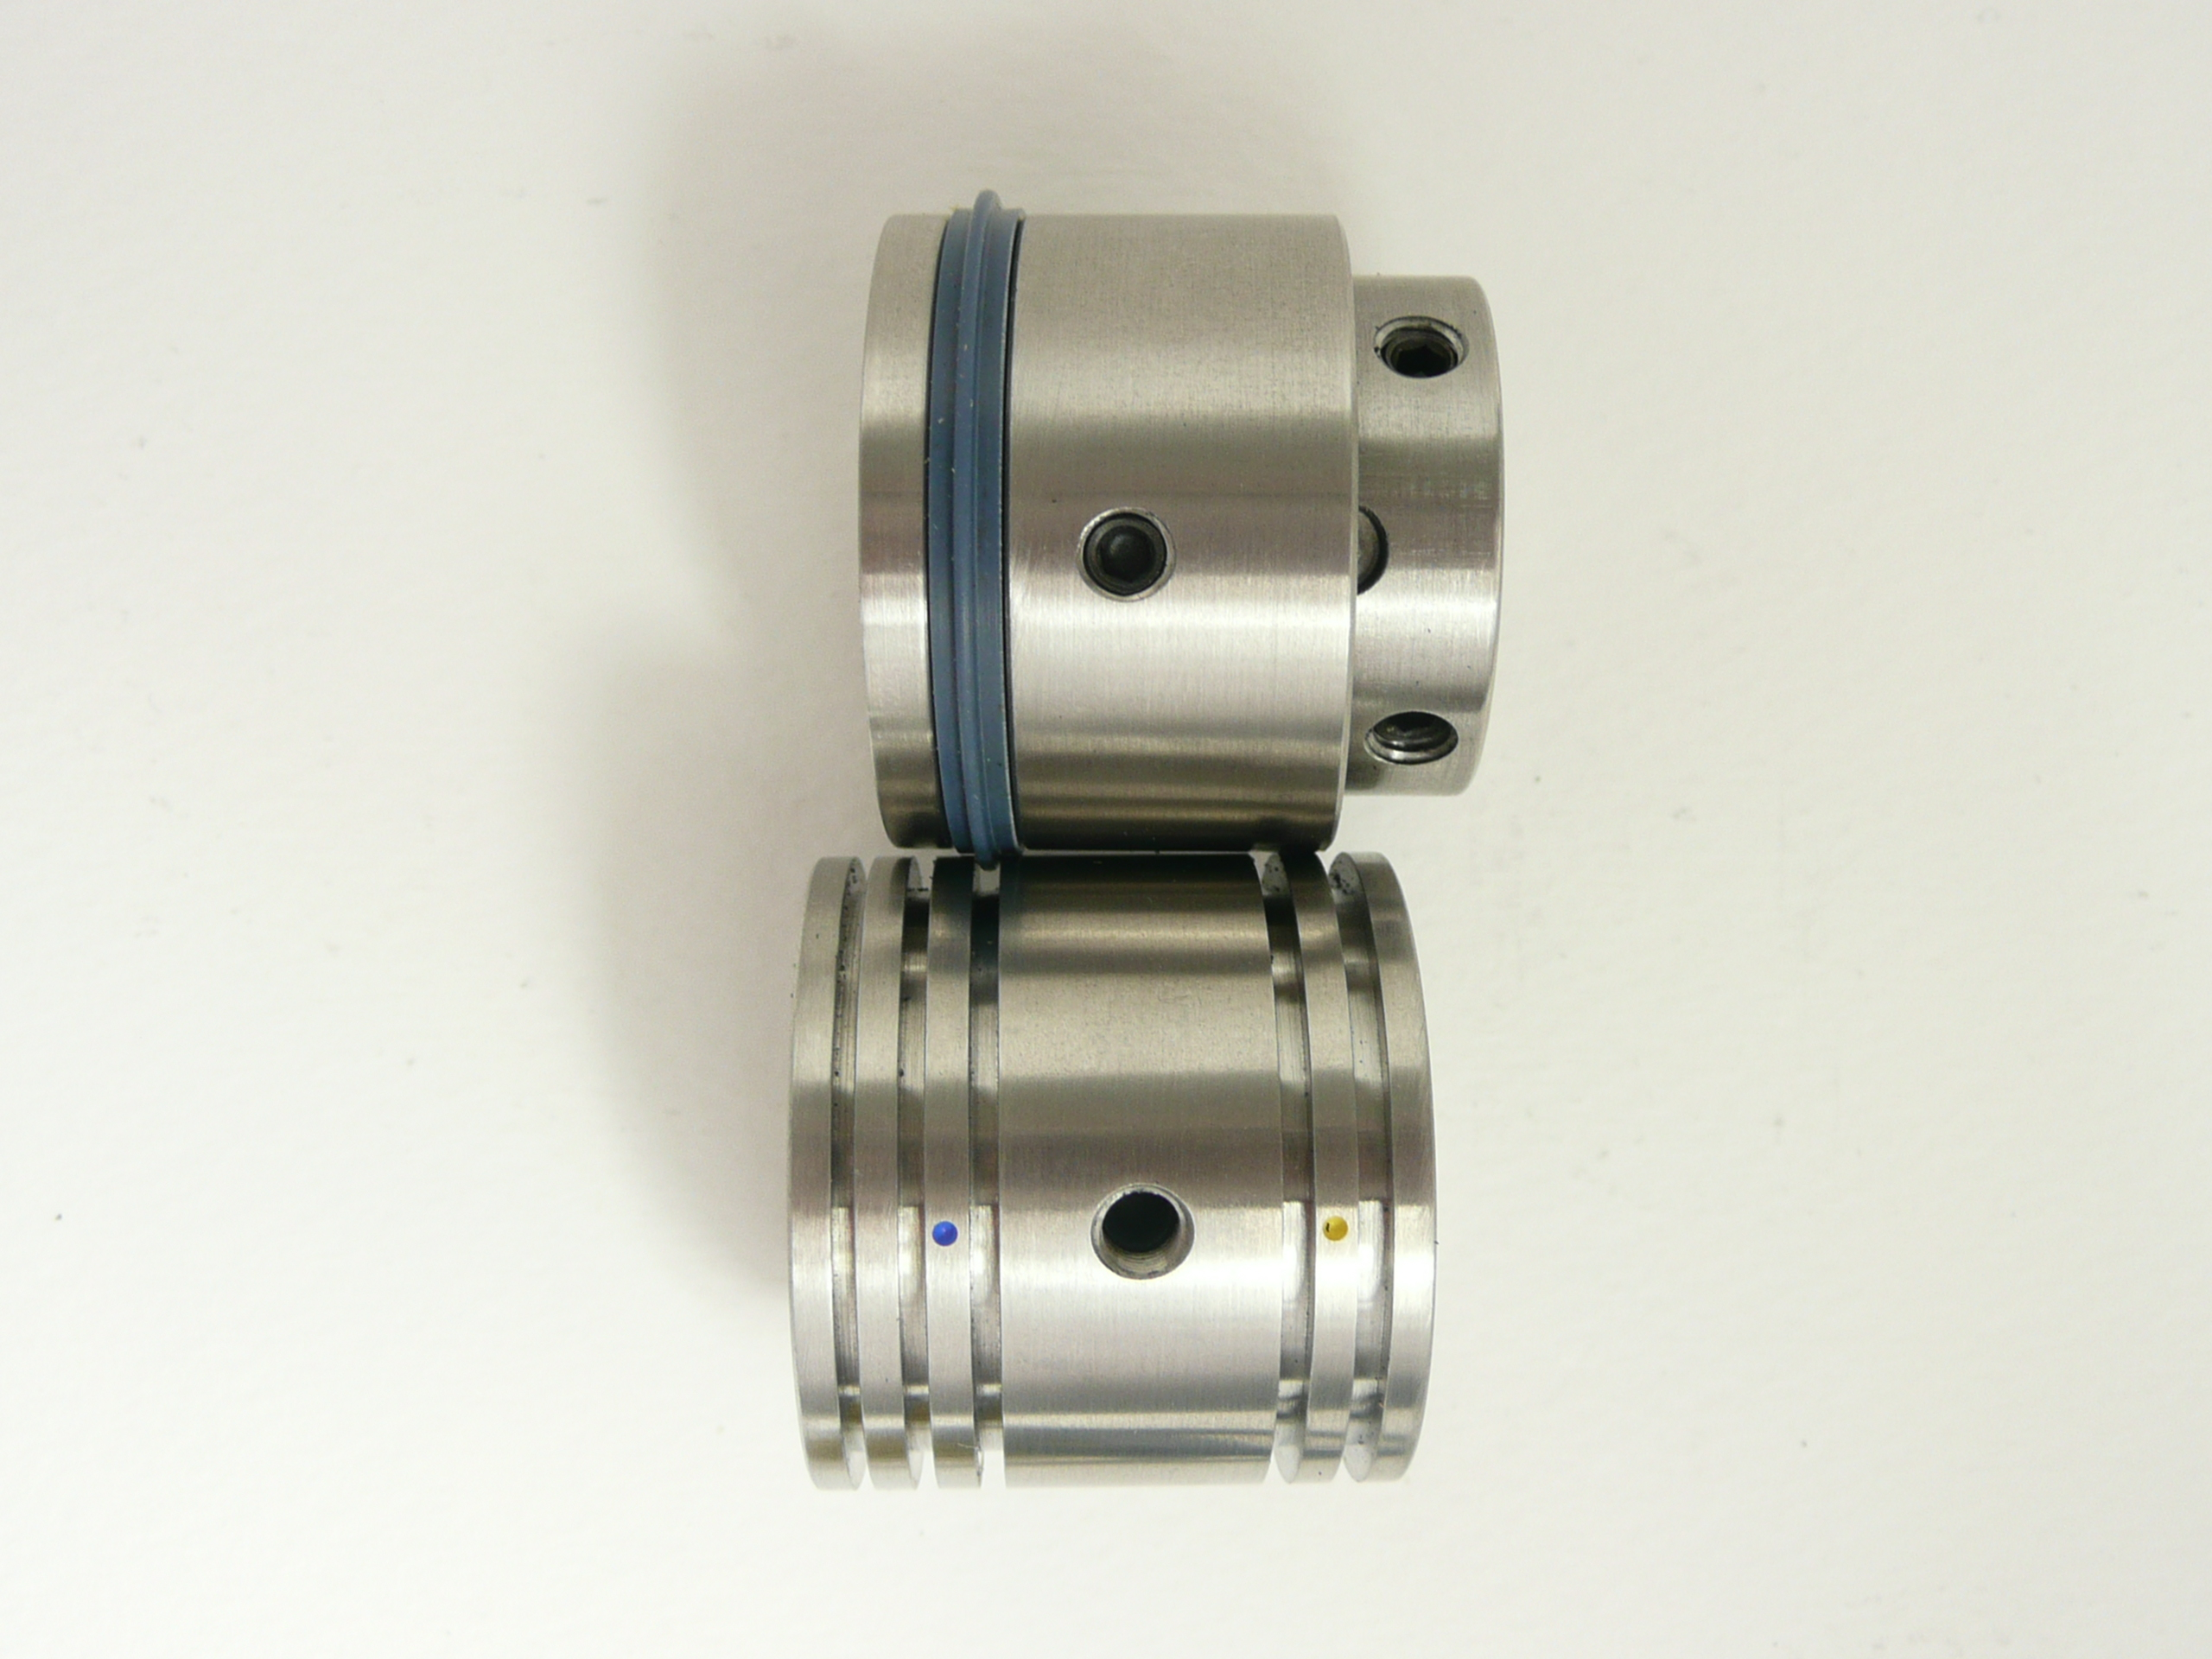
Shaft fixing screws
5 widths of female channel
The narrower the channel the thinner the paper stock

When positioning the male please tighten the male into the correct crease position and tighten onto the shaft. With the female still loose on the shaft hand turn a sheet a heavy stock between the male and female. This will automatically move the female into the centre of the creasing rib. Hand turn the sheet until the female fixing screws become visible and then tighten onto shaft.
The crease rib and the female will now be in the optimum creasing position.

It is important to place the coloured crease insert into the correct female channel

If tearing on the front edge occurs place the crease rib into a NARROWER channel

Some times the Morgana rubber support roller become smaller on the outer diameter. This makes the 2 exit shafts come closer together than they should. If the support collars become too small, the Technifold creasing unit will cut the sheets on the crease.
To check the support collar size ( 30mm outer diameter) wrap some sellotape around the support collars to build them up to the correct size. If this works we suggest you replace the old support collars as they are worn out.

